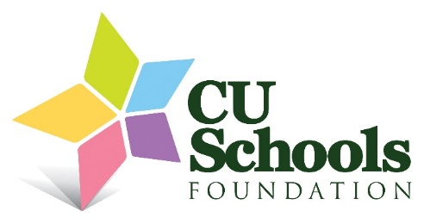
2025 – 2026 Gift of the Fine Arts Grant
Sherrie Hildreth – King Elementary
Krannert (KCPA) Adventures
Our third-grade students have the opportunity to attend the Kaki King Bugs performance in November and the fourth-grade students will attend the Cirque Kalabanté performance in January at the Krannert Center for Performing Arts. This is a total of at least 100 students who can compare what we are learning in classes to professional performances at the university. With us being a school that has 87% low income across the K-5 grades, being able to attend these performances is amazing!
Lane Cannon-Gjerde – Yankee Ridge Elementary
"One Stage, Many Stories"
This grant will purchase reusable back drops so that all 550 students have access to a believable looking stage and set. Students begin to learn about sets and scenery in kindergarten and we expand on sets through 2nd grade where students put on a play, this continues all the way to 5th grade where students write their own monologues and perform.
Lorena Cuenca Ramon – Yankee Ridge Elementary
Graduation Catwalk: From everyday materials to wearable Art
This project will engage 5th grade students in fashion design by transforming everyday and unconventional materials—such as cardboard, paper, fabric scraps, and balloons—into creative wearable art. The goal is to inspire imagination, sustainability, and problem-solving through the reimagining of common items as artistic resources. Students will design and construct their pieces in art class, culminating in a catwalk performance during the 5th grade graduation celebration. Amount

