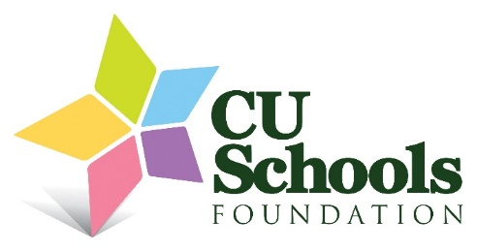
2025–2026 Career Awareness Grants
Urbana High School – Nathan Westerman
UHS HVAC Career Exploration
Industrial Technology, Welding, and Engineering students will visit Parkland College’s HVAC program and A&R Mechanical to explore education and career paths in HVAC. Students will also build sheet-metal toolboxes using grant-funded tools.
Grant: $3,000 | Students Served: 65+
Urbana High School – Amanda Rosser-Perez
Career Fair
UHS will host its first career fair in partnership with the Chamber of Commerce, connecting students with local employers and offering hands-on hospitality experience for culinary students.
Grant: $1,400 | Students Served: 300+
Urbana Middle School – Janice Knight
Diverse Careers in Art and Design
Eighth-grade art students will visit the Krannert Art Museum and Siebel Center for Design at the University of Illinois to learn about art and design professions.
Grant: $1,000 | Students Served: 60
International Prep Academy – Molly Hooper
Bike Repair Skills
Students will learn the fundamentals of bike maintenance while exploring technical and mechanical career pathways. Learning the mechanics of how a bike works will provide students with an understanding of the physics of motion, as well as how to maintain equipment.
Grant: $500 | Students Served: 60

