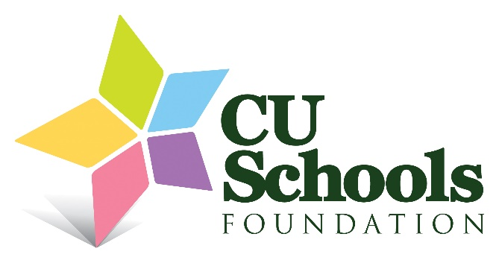
2025-2026 CUSF Book Grant Recipients
Teacher |  | School
Elizabeth | Abbott | Kenwood Elementary School
Corymar | Bernacet | Urbana Middle School
Madison | Blackburn | Barkstall Elementary
Abbey | Brinkoetter | Carrie Busey Elementary
Jillian | Cappa | Central High School
Joy | Cordes | Edison Middle School
Lacie | Douglas | Carrie Busey Elementary
Johnna | Dunne | Stratton Academy of the Arts
Karen | Easton | Edison Middle School
Alexis | Gatses | Stratton Academy of the Arts
Amanda | Gilliland | Kenwood Elementary School
Michele | Hall | Urbana Early Childhood
Kennedy | Hall | Robeson Elementary School
Steve | Hicks | Urbana Middle School
Kallie-Jo | Ho | Edison Middle School
Jessica | Hutchison | Centennial High School
Jenna | Keller | Franklin STEAM Academy
Kate | Krusell | Elementary Schools
Dana | Lipari | Barkstall Elementary
Cristina | Montanola Hernandez | Urbana High School
Minsoo | Park | Booker T. Washington STEM Academy
Tegan | Rehn | Dr. Martin Luther King Jr.
Barbara | Sebens | Dr. Martin Luther King Jr.
Stephanie | VanDeventer | Booker T. Washington STEM Academy
Stacey | Voelker | Champaign Early Childhood Center

